User Guide for Light Version of BooksStock.API
- After extracting files from zip archive, run BookStore.API.exe
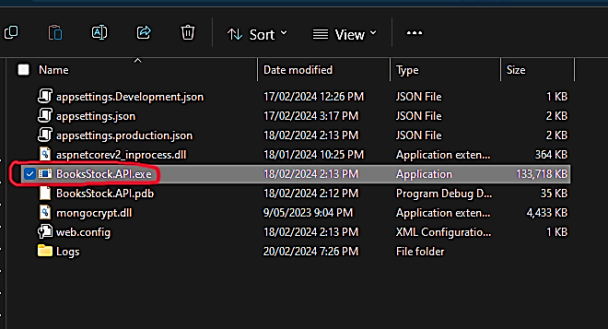
- Open any internet browser and enter address: http://localhost:5000/swagger/index.html
ATTENTION: localhost supports only http.
- Press arrow icon in righthand side:
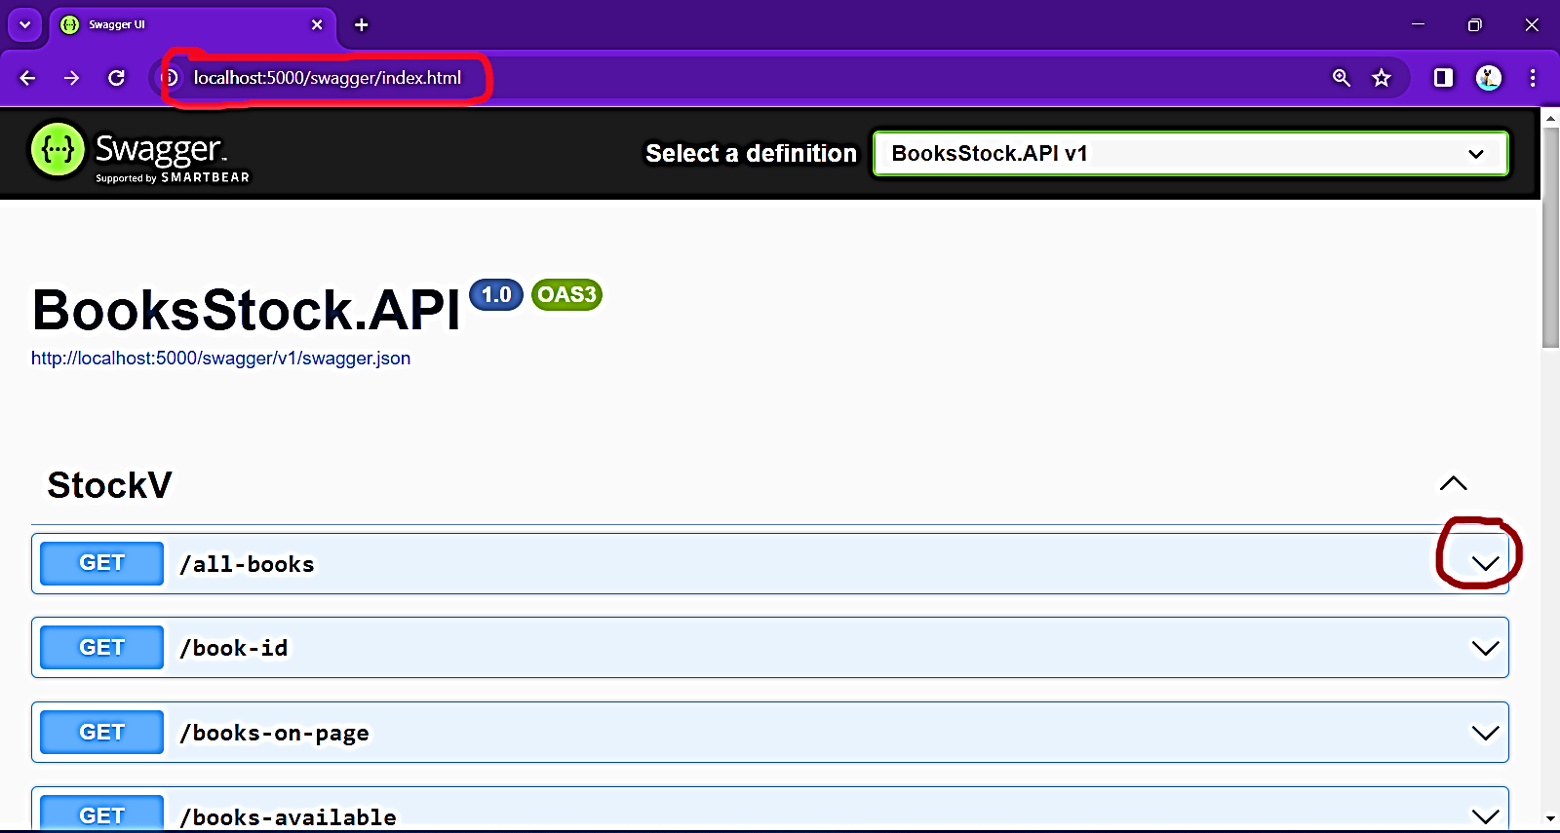
- Press button “Try it out” in right hand side:
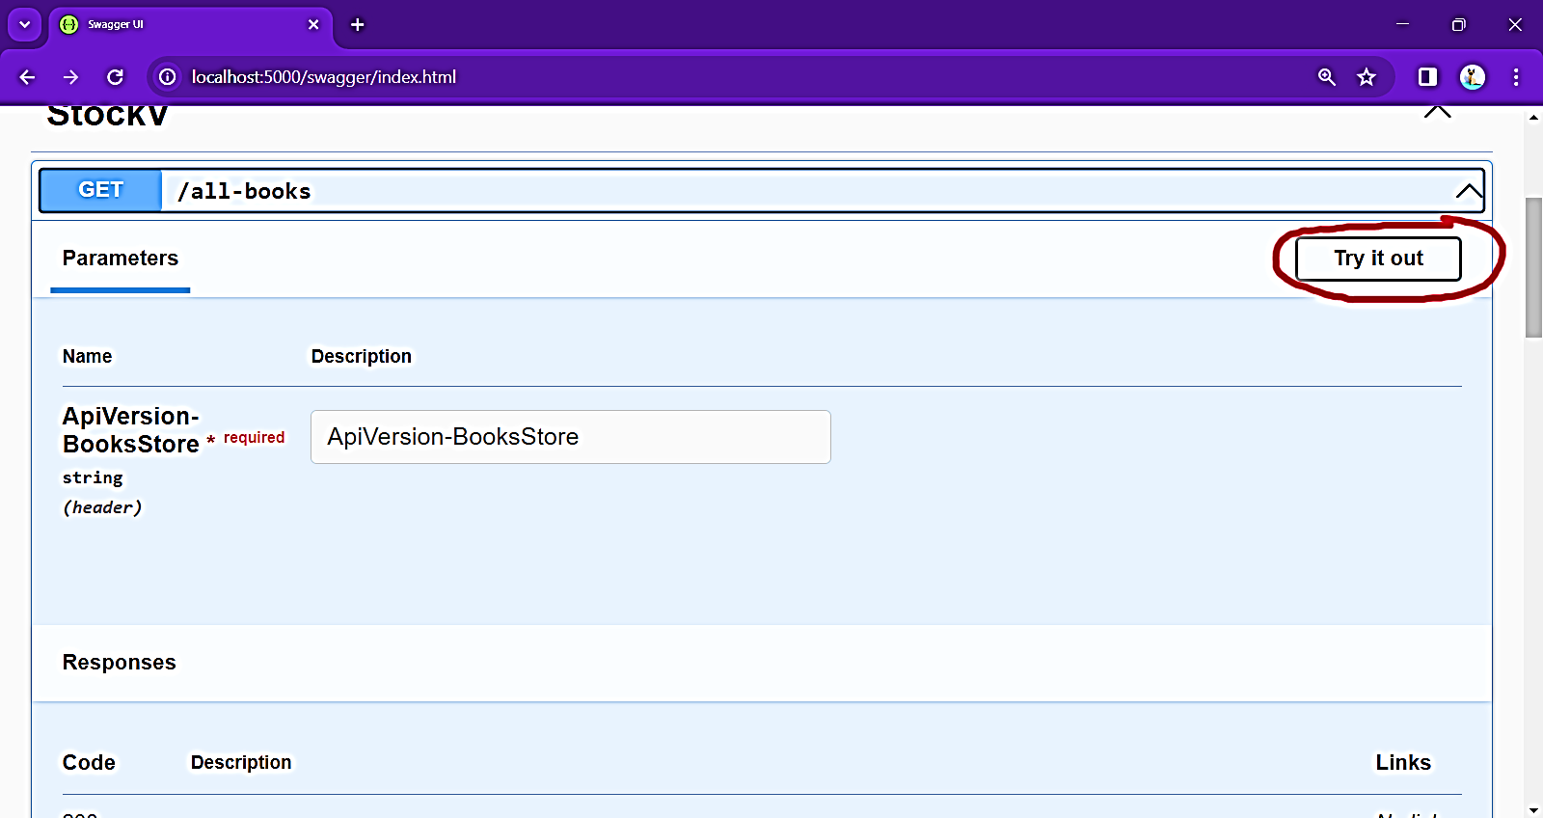
- In ApiVersion-BooksStore enter 1 or 2, to use API version 1 – enter “1” supports all methods (GET, POST, DELETE and PUT), and retrieves all data from database, or to use API version 2 – enter “2” (supports only some GET methods), and retrieves only available from database:
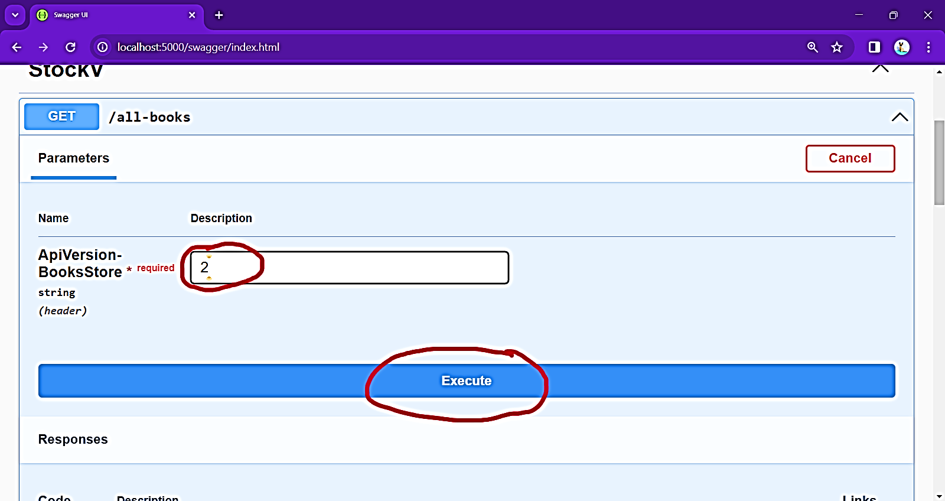
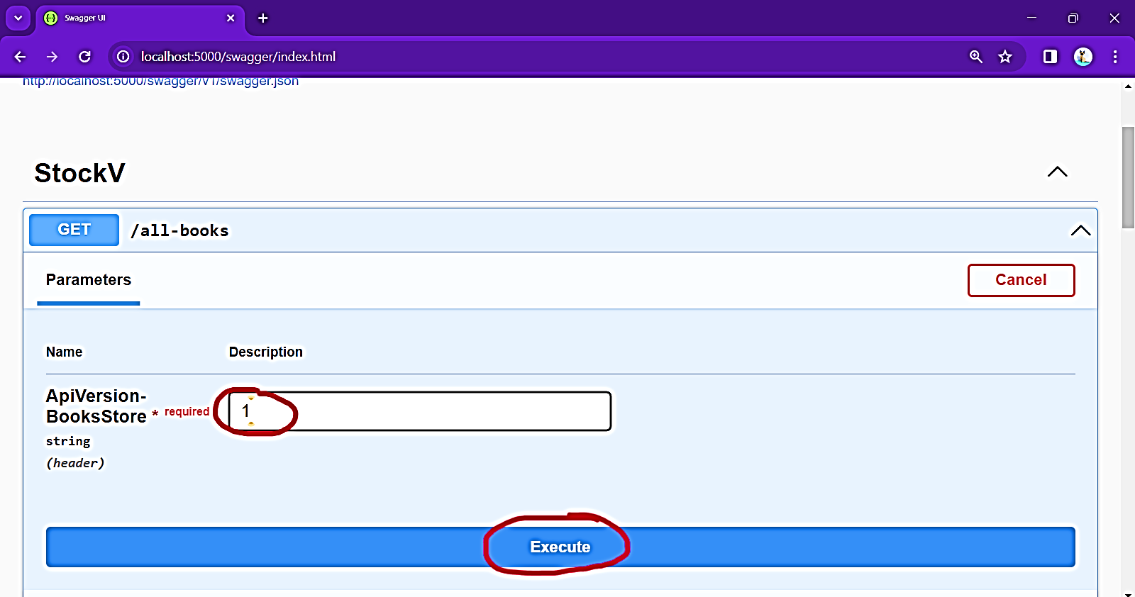
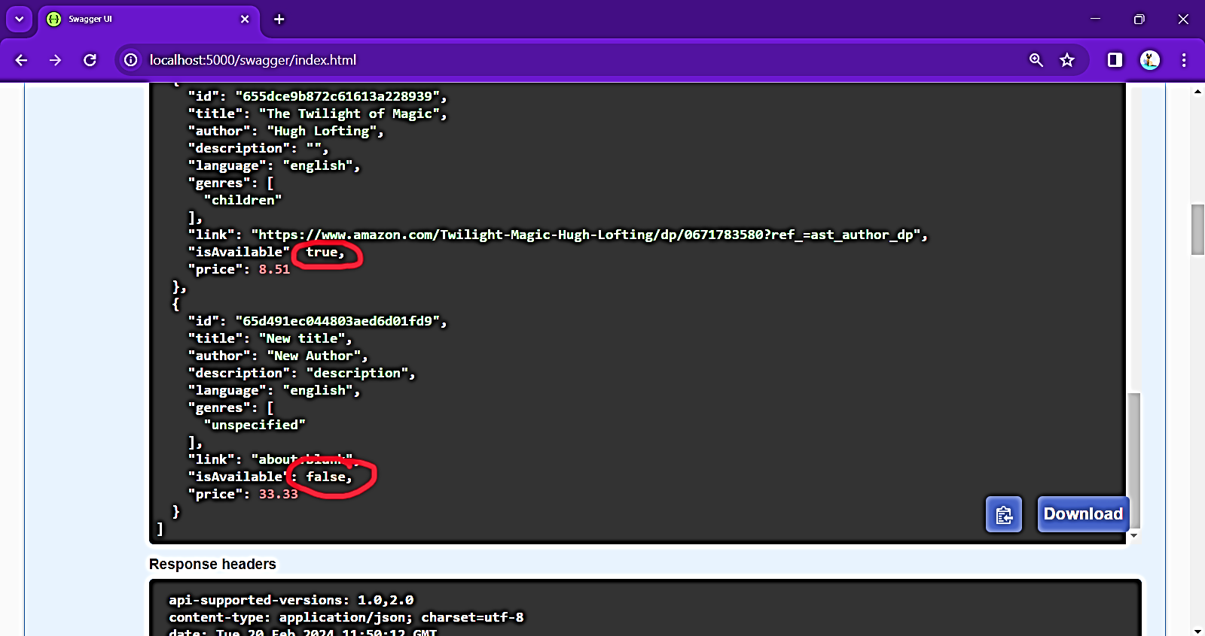

Short description of all methods:
Methods: | Supports: | Description
GET/all-books | ApiVersion-BooksStore : 1  ApiVersion-BooksStore : 2 | Retrieves all data from database.  For ApiVersion-BooksStore : 2 retrieves only were parameter “isAvailable” : true
GET/book-id | ApiVersion-BooksStore : 1 | Gets book by “id”
GET/books-on-page | ApiVersion-BooksStore : 1  ApiVersion-BooksStore : 2 | Retrieves all data from database, with requested page and requested quantity per page (divides all data from database into pages) and sorts the data in ascending or descending order.  For ApiVersion-BooksStore : 2 retrieves only were parameter “isAvailable” : true
GET/books-available | ApiVersion-BooksStore : 1 | Retrieves all data from database with requested available - “isAvailable”: true or false
GET/books-available-page | ApiVersion-BooksStore : 1 | Retrieves all data from database with requested page, quantity of books per page and available - “isAvailable”: true or false
GET/genres | ApiVersion-BooksStore : 1  ApiVersion-BooksStore : 2 | Gets the list of all genres in database. For ApiVersion-BookStore: 2 only genres where at least one book “isAvailable” : true
GET/books-equals-condition | ApiVersion-BooksStore : 1  ApiVersion-BooksStore : 2 | Gets all books where at least one property equals to the entered term, For ApiVersion-BookStore: 2, only books “isAvailable” : true
GET/books-equals-condition-page | ApiVersion-BooksStore : 1  ApiVersion-BooksStore : 2 | Same as previous, just divides content into pages, with requested quantity per page.
GET/books-contains-condition | ApiVersion-BooksStore : 1  ApiVersion-BooksStore : 2 | Gets all books where at least one property contains to the entered term, For ApiVersion-BookStore: 2, only books “isAvailable” : true
GET/books-contains-condition-page | ApiVersion-BooksStore : 1  ApiVersion-BooksStore : 2 | Same as previous, just divides content into pages, with requested quantity per page.
GET/books-filtered | ApiVersion-BooksStore : 1  ApiVersion-BooksStore : 2 | Gets all books where data in each property contains entered data for each property. For ApiVersion-BookStore: 2, only books “isAvailable” : true.
GET/books-filtered -page | ApiVersion-BooksStore : 1  ApiVersion-BooksStore : 2 | Same as previous, just divides content into pages, with requested quantity per page.
GET/all-books-count | ApiVersion-BooksStore : 1  ApiVersion-BooksStore : 2 | Returns quantity of all books in database. For ApiVersion-BookStore: 2, only counts books “isAvailable” : true.
GET/all-available-count | ApiVersion-BooksStore : 1 | Returns quantity of all books in database, where parameter available - “isAvailable” : as requested.
GET/books-genre-count | ApiVersion-BooksStore : 1  ApiVersion-BooksStore : 2 | Returns quantity of books under requested genre. For ApiVersion-BookStore: 2, only counts books “isAvailable” : true.
POST/book-add | ApiVersion-BooksStore : 1 | Add new book/data in database. Requires entering all data, except the Id, Id generated automatically.
PUT/book-update | ApiVersion-BooksStore : 1 | Update/Change existing book/data in database, by Id. Myst be entered Id, IsAvailable. Rest data that was not entered would be kept the current. ATTENTION if need to add new genre, but keep the currents, then all genres that needs to be kept must be entered, otherwise they would be deleted or should not enter any new.
DELETE/book-delete | ApiVersion-BooksStore : 1 | Delete existing book/data from database.  Requires existing Id.

